Running a serverless application on AWS involves several key steps. Below is a high-level overview of the procedures to deploy and run a serverless application using AWS services such as AWS Lambda, API Gateway, and AWS SAM (Serverless Application Model).

1. **Set Up Your AWS Environment**

- **Create an AWS Account**: If you don't have an AWS account, create one at [aws.amazon.com](https://aws.amazon.com).

- **Install AWS CLI**: Download and install the AWS Command Line Interface (CLI) on your local machine.

- **Configure AWS CLI**: Run `aws configure` in your terminal and provide your AWS Access Key, Secret Key, region, and output format.

2. **Design Your Serverless Architecture**

- **Define Your Application Logic**: Determine what parts of your application will run as serverless functions (e.g., using AWS Lambda).

- **Identify Event Sources**: Choose the AWS services that will trigger your Lambda functions (e.g., API Gateway, S3, DynamoDB, etc.).

- **Choose Data Storage**: Decide on the storage services you will use, such as Amazon S3 for object storage or DynamoDB for NoSQL databases.

3. **Develop Your Lambda Functions**

- **Write Your Function Code**: Create the code that will run in your Lambda functions. AWS Lambda supports various languages like Python, Node.js, Java, and more.

- **Package Your Code**: Bundle your application code and dependencies. You can do this manually or use tools like AWS SAM or the Serverless Framework to automate packaging.

4. **Deploy Your Serverless Application**

- **Use AWS SAM or Serverless Framework**: AWS SAM simplifies deploying serverless applications by allowing you to define your application in a template file (YAML).

- Example of a SAM template

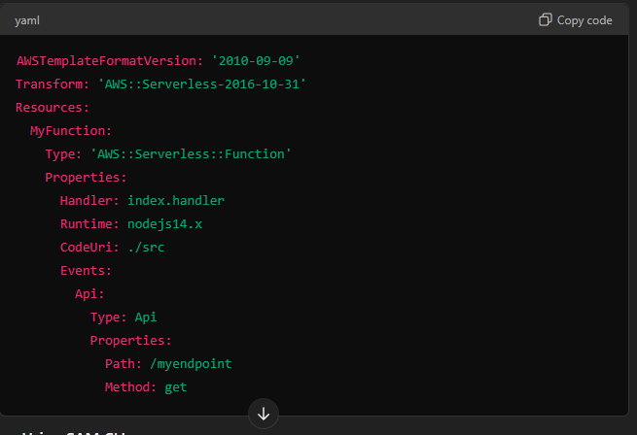

Source Code:

yaml

AWSTemplateFormatVersion: '2010-09-09'

Transform: 'AWS::Serverless-2016-10-31'

Resources:

MyFunction:

Type: 'AWS::Serverless::Function'

Properties:

Handler: index.handler

Runtime: nodejs14.x

CodeUri: ./src

Events:

Api:

Type: Api

Properties:

Path: /myendpoint

Method: get

```

- **Deploy Using SAM CLI**:

- Build the application: `sam build`

- Deploy the application: `sam deploy --guided`

- **Manual Deployment**: Alternatively, you can upload the Lambda function code manually via the AWS Management Console.

5. **Configure Event Sources**

- **Set Up API Gateway**: Create a new API in Amazon API Gateway and link it to your Lambda function. This will allow your function to be triggered via HTTP requests.

- **Set Up S3 Events**: If using S3 as an event source, configure bucket notifications to trigger your Lambda function when certain actions (e.g., file uploads) occur.

6. **Monitor and Scale Your Application**

- **Use CloudWatch**: Monitor your application’s performance using AWS CloudWatch. Set up logs and metrics to track usage and troubleshoot issues.

- **Auto Scaling**: AWS Lambda automatically scales your function in response to incoming events, so you don’t need to manage servers.

7. **Secure Your Application**

- **IAM Roles and Policies**: Assign appropriate AWS Identity and Access Management (IAM) roles and policies to your Lambda functions to control permissions.

- **API Gateway Security**: Use API Gateway to enforce security mechanisms like API keys, throttling, and request validation.

8. **Optimize and Maintain**

- **Cost Management**: Monitor your usage and optimize to ensure cost efficiency.

- **Version Control**: Utilize Lambda versioning and aliases to manage updates to your functions without disrupting the production environment.

- **CI/CD Integration**: Integrate with CI/CD pipelines for automated deployment and testing.

9. **Test Your Application**

- **Unit and Integration Testing**: Test your functions locally using tools like SAM CLI (`sam local invoke`) or the Serverless Framework.

- **End-to-End Testing**: Deploy to a staging environment and test the full workflow of your application.

10. **Go Live and Maintain**

- **Deploy to Production**: Once your application is tested, deploy it to the production environment.

- **Monitor**: Continuously monitor the application and make improvements as needed.

This process will help you effectively deploy and manage a serverless application on AWS.

For further Reference …

https://chatgpt.com/c/68b45cf9-f8a9-487d-a954-2c21d7890261